FCAT Science Grade 8 Remediation Plan- Week 1
Ms. McCoy, DHMS This plan includes the remediation assignments that will be given for FCAT preparation in Ms. McCoy’s class. I plan to use learning stations each week focusing on remediation benchmarks. Bell work will be given each day to review benchmarks as well. A pre assessment and post assessment will be given along with a correctives plan. I will be giving a 10 question pre assessment and post assessment each week, based on the remediation benchmarks for that week. Also, Honors will start remediation at the same time as Comp science/regular because they need it. We will begin the first week of Genetics in Honors, and we will finish the unit after FCAT.
Remediation Calendar for Honors and Comp Science.
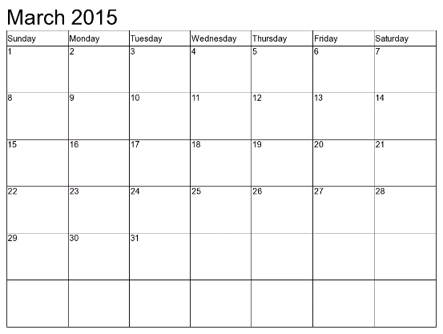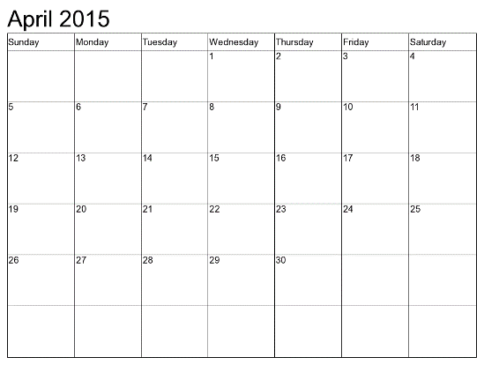
March 17-April 10th
Remediated Benchmarks and Stations for this week  SC.6.L.15.1  SC.6.L.14.4  SC.7.L.17.2  SC.6.L.14.2  SC.6.L.14.1  SC.6.L.14.5  SC.7.L.15.2  SC.7.L.16.1 | Monday | Tuesday March 17  Station 1- Complete FRAME notes on the kingdoms and domains. | Wednesday  March 18  Station 2- Compare and Contrast plant and animal cells. | Thursday  March 19  Station 3-  PBS Evolution webquest  http://www.pbs.org/wgbh/evolution/educators/lessons/index.html | Friday  March 20th  Whole Class Activity -Sponge Bob Genetics  Post Test Monday.
Remediated Benchmarks and Stations for this week  SC.6.E.7.4  SC.6.E.7.5  SC.7.E.6.5  SC.7.E.6.2  SC.7.E.6.4 | Monday  March 23 | Tuesday  March 24 | Wednesday  March 25 | Thursday  March 26 | Friday  March 27
Remediated Benchmarks Stations and for this week  SC.7.P.11.2  SC.7.P.10.3  SC.6.P.13.1  SC.7.P.10.1  SC.6.P.13.3  SC.7.P.11.4 | Monday  April 6 | Tuesday  April 7 | Wednesday  April 8 | Thursday  April 9 | Friday  April 10

Remediated Benchmarks
SC.6.E.7.4- Differentiate and show interactions among the geosphere, hydrosphere, cryosphere, atmosphere, and biosphere.
SC.6.L.15.1- Analyze and describe how and why organisms are classified according to shared characteristics with emphasis on the Linnaean system combined with the concept of Domains.
SC.7.P.11.2- Investigate and describe the transformation of energy from one form to another.
SC.6.E.7.5- Explain how energy provided by the sun influences global patterns of atmospheric movement and the temperature differences between air, water, and land.
SC.6.L.14.4- Compare and contrast the structure and function of major organelles of plant and animal cells, including cell wall, cell membrane, nucleus, cytoplasm, chloroplasts, mitochondria, and vacuoles.
SC.7.P.10.3 Recognize that light waves, sound waves, and other waves move at different speeds in different materials.
SC.7.L.17.2- Compare and contrast the relationships among organisms such as mutualism, predation, parasitism, competition, and commensalism.
SC.6.P.13.1- Investigate and describe types of forces including contact forces and forces acting at a distance, such as electrical, magnetic, and gravitational.
SC.6.L.14.2- Investigate and explain the components of the scientific theory of cells (cell theory): all organisms are composed of cells (single-celled or multi-cellular), all cells come from pre-existing cells, and cells are the basic unit of life.
SC.7.E.6.5- Explore the scientific theory of plate tectonics by describing how the movement of Earth's crustal plates causes both slow and rapid changes in Earth's surface, including volcanic eruptions, earthquakes, and mountain building.
SC.7.P.10.1- Illustrate that the sun's energy arrives as radiation with a wide range of wavelengths, including infrared, visible, and ultraviolet, and that white light is made up of a spectrum of many different colors.
SC.6.P.13.3- Investigate and describe that an unbalanced force acting on an object changes its speed, or direction of motion, or both.
SC.7.P.11.4- Observe and describe that heat flows in predictable ways, moving from warmer objects to cooler ones until they reach the same temperature.
SC.6.L.14.1- Describe and identify patterns in the hierarchical organization of organisms from atoms to molecules and cells to tissues to organs to organ systems to organisms.
SC.6.L.14.5- Identify and investigate the general functions of the major systems of the human body (digestive, respiratory, circulatory, reproductive, excretory, immune, nervous, and musculoskeletal) and describe ways these systems interact with each other to maintain homeostasis.
SC.7.L.15.2- Explore the scientific theory of evolution by recognizing and explaining ways in which genetic variation and environmental factors contribute to evolution by natural selection and diversity of organisms.
SC.7.L.16.1- Understand and explain that every organism requires a set of instructions that specifies its traits, that this hereditary information (DNA) contains genes located in the chromosomes of each cell, and that heredity is the passage of these instructions from one generation to another.
SC.7.E.6.2- Identify the patterns within the rock cycle and relate them to surface events (weathering and erosion) and sub-surface events (plate tectonics and mountain building).
SC.7.E.6.4- Explain and give examples of how physical evidence supports scientific theories that Earth has evolved over geologic time due to natural processes.

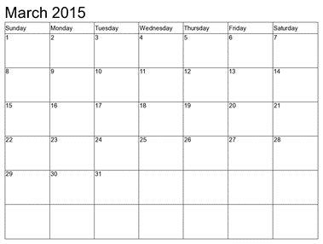
Name__________________________ Class______________ DUE: ___________
Weekly BELL/HOMEWORK: Science
FCAT Remediation

TUESDAY WEDNESDAY THURSDAY FRIDAY

17  Weekly Standard  Area of Emphasis  SC.6.L.15.1, SC.7.L.17.2  TASK TO COMPLETE  Bellwork  Watch https://www.youtube.com/watch?v=A9EKofyJbng  During the video, Complete your flash card for each term  mutualism, predation, parasitism, competition, and commensalism.  After completing Flash Cards, create a venn diagram comparing and contrasting the relationship between organisms.  Homework  Answer  1.Explain-What role does adaptation play in predation?  2.How and why do scientists classify organisms?  3.What are the different domains organisms are classified into? 4.What are the distinguishing characteristics of each kingdom?  DUE FRIDAY | 18  Weekly Standard  Area of Emphasis  SC.6.L.14.2, SC.6.L.14.4  TASK TO COMPLETE  Bellwork  Watch  https://www.youtube.com/watch?v=4OpBylwH9DU&list=PLAuJGYL6VYK-XsO_UlLyDXJcImcmx_RmK&index=2  During the video, write what each a summary to each part of the cell theory.  Homework- For the rest of the week, work on your correctives and have Tuesdays work/answers ready by Friday  DUE FRIDAY | 19  Weekly Standard  Area of Emphasis  SC.6.L.14.5, SC.6.L.14.1  TASK TO COMPLETE  Bellwork  Watch  https://www.youtube.com/watch?v=Wq3TpADAc0Y  During video  System Function Organs  Give 4 examples of how different body systems interact to maintain homeostasis in the body.  Put the following in order and give a description of each  Organisms, tissue, organ, molecule cell, organ system, atom.  Homework- For the rest of the week, work on your correctives and have Tuesdays work/answers ready by Friday  DUE FRIDAY | 20  Weekly Standard  Area of Emphasis  SC.7.L.15.2, SC.7.L.16.1  TASK TO COMPLETE  Bellwork  Watch  https://www.youtube.com/watch?v=m1OAPe3UZiQ  Explain in your own words the scientific theory of evolution and “ survival of the fittest”  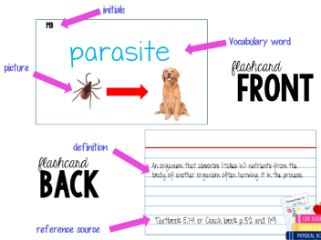  Remember for Flash Cards  FRONT OF CARD: Word, Picture, Initials in top left corner BACK OF CARD: , Definition in your own words , Source  DUE FRIDAY
Staple this sheet to the front of your completed homework packet prior to submitting it on Friday.
Bell/Homework Packet ____/100 Station Work____/300 Correctives_____/100

Pre/Post Assessment Week 1 Name:____________________________
1. Which characteristic is common to animals, plants, protists, and fungi?  a. ability to make their own food  b. eukaryotic cells  c. ability to move  d. multicellular structure | 6. Question : A certain reptile species is a herbivore and exists only on an isolated island. Which of the following would most likely result in the extinction of the reptile species over a period of twenty thousand years?  Answer Options:  A. The reptile species produces many offspring with many unique traits, and the vegetation remains constant.  B. The reptile species produces few offspring with some unique traits, and the vegetation remains constant.  C. The reptile species produces few offspring with no unique traits, and the vegetation changes quickly.  D. The reptile species produces many offspring with some unique traits, and the vegetation changes slowly.
2. Which group includes the most species?  a. kingdom b. family c. domain d. phylum | 7. Genetic material is contained within the ___ of the cell.  A.ribosomes  B.cytoplasm  C.nucleus  D.nucleolus
3. Which of the following statements describes how these organisms are an example of the cell theory?  Answer Options:  A. The organisms have cells that lack a nucleus.  B. The organisms are made of one or more cells.  C. The cells of the organisms undergo photosynthesis.  D. The cells of the organisms are identical to each other.  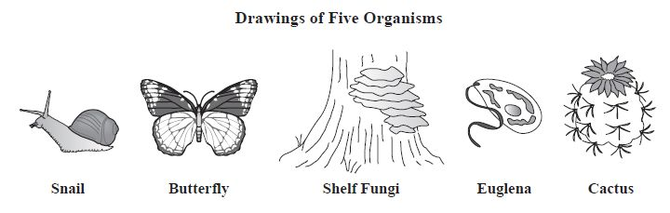 | 8. Question:  The gene for curled ears (C) is dominant over the gene for straight ears (c). If you have a cat with curled ears (Cc) and a cat with straight ears (cc).  What percent of the offspring are expected to have curled ears as a result of a cross between the cats shown?  Answer Options:  A. 100  B. 75  C. 50  D. 25
4. Question:  In order to maintain homeostasis, the systems of the human body work together to keep a constant internal temperature. Which of the following statements describes how the human body responds in a cold environment?  Answer Options:  A. The nervous system moves the jaw bones and causes the chattering of teeth.  B. The nervous system signals the muscles of the muscular system to contract and warm the body.  C. The circulatory system delivers less carbon dioxide to the muscular system, resulting in stiffening of the muscles.  D. The skeletal system produces more blood cells that circulate through the blood vessels, increasing the warmth of the body. | 9. Which of the following is not part of the cell theory?  A. all living things are made of cells  B. cells come from existing cells  C. cells are the basic units of structure and function in all living things  D. all cells contain the same organelles
5. A picture of which of the following structures belongs in the box above? A. cell B. organ C. organelle D. tissue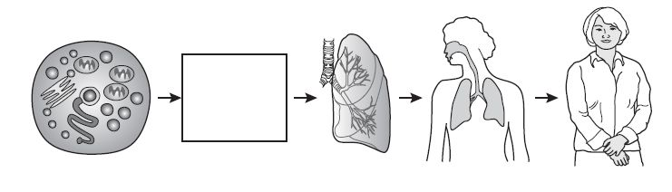 | 10. Which process is best illustrated by the diagram?  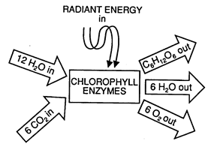  A. cellular respiration B. digestion  C. photosynthesis D. fermentation

Name_____________________________________ Date______________ Week________ Period___________
Pre Test Correctives-Making it count for FCAT!

Question | Right or Wrong | Correct Answer | Explain in Detail why this is the correct answer

Question | Right or Wrong | Correct answer | Explain in Detail why this is the correct answer

